Table of Contents

Gotoro: Guideline to Create OKE 1

Gotoro: Guideline to Connect to OKE 1

Gotoro: Guideline to Install ArgoCD. 1

Gotoro: Document for add repo helm chart on ArgoCD. 1

# Gotoro: Guideline to Create OKE

Step 1: Login Oracle Cloud: [Oracle Cloud Infrastructure](https://cloud.oracle.com/?region=us-ashburn-1). Go to **Develoer Services** > **Kubernetes Cluster**.

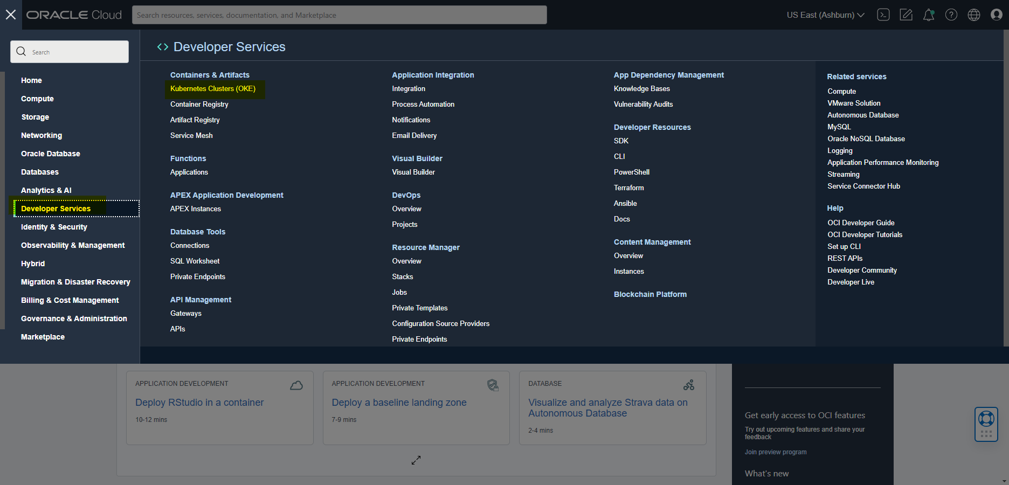

Step 2: Chose **Compartment** for your environment and **Create Cluster**.

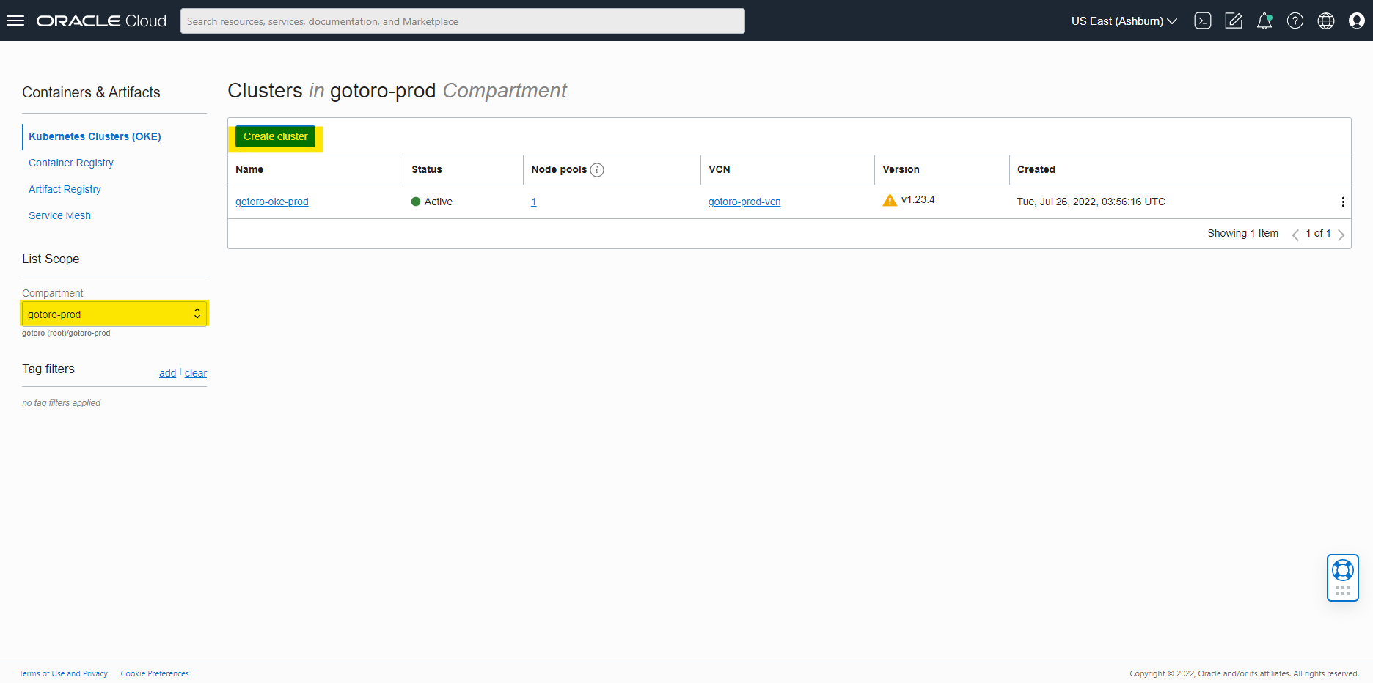

Step 3: Select **Custom create.**

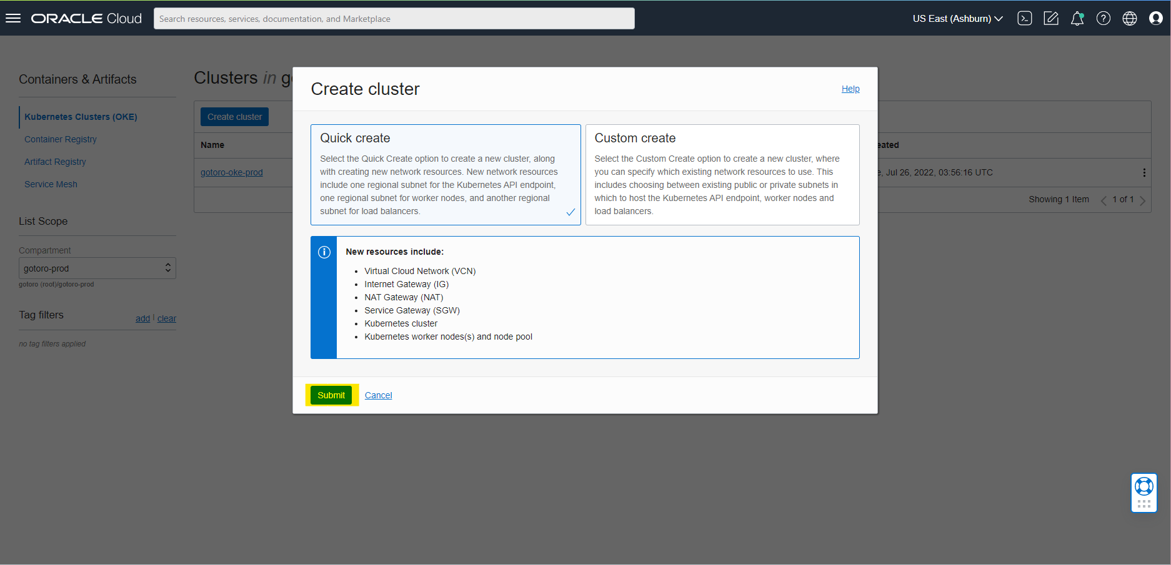

Step 4: Fill information and next.

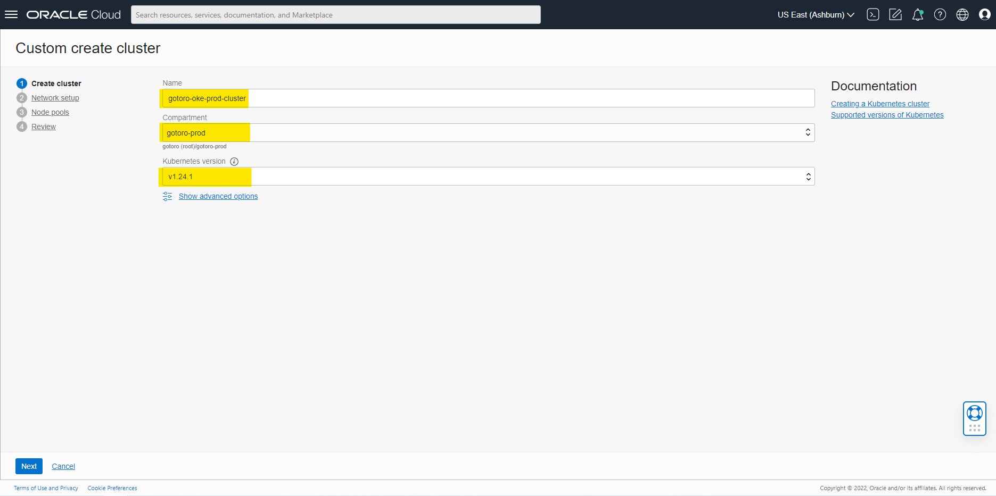

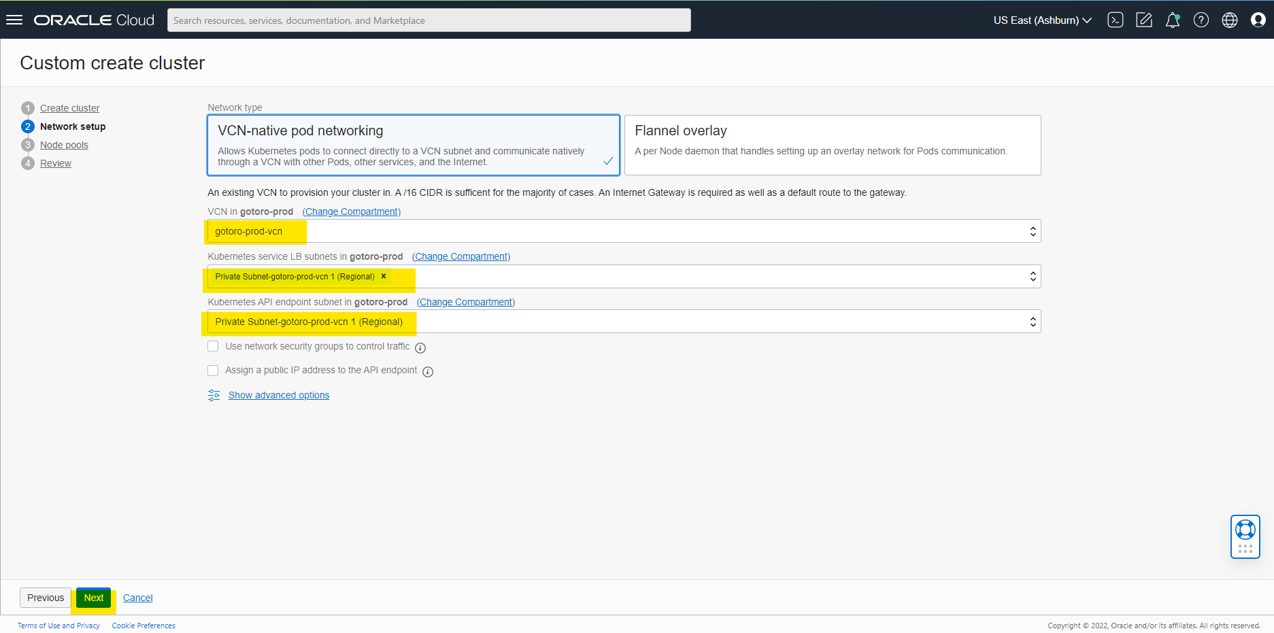

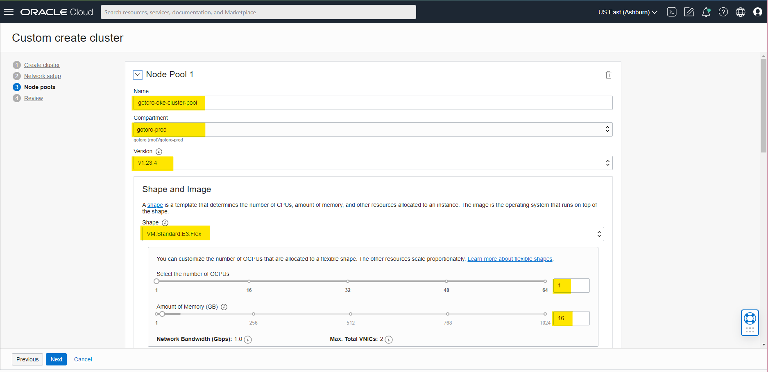

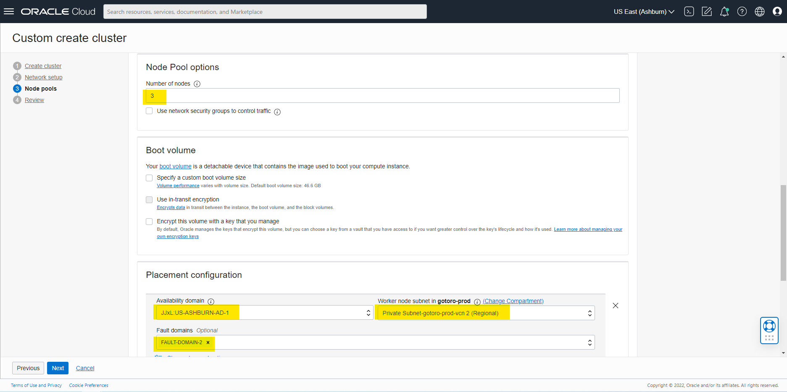

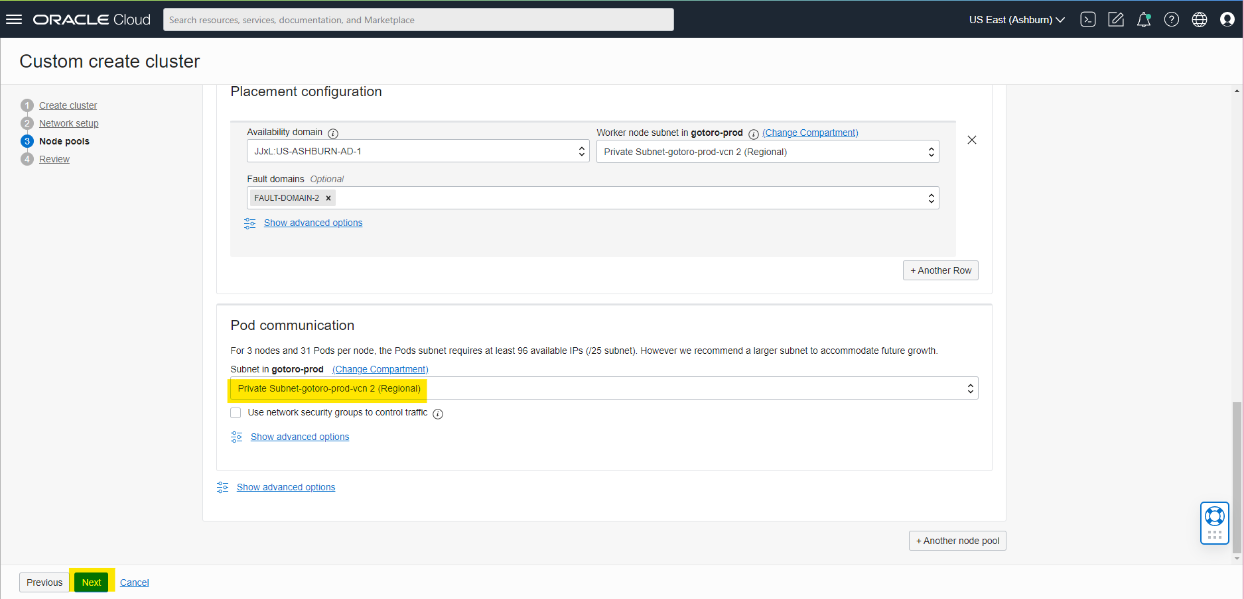



Step 5: Review status.

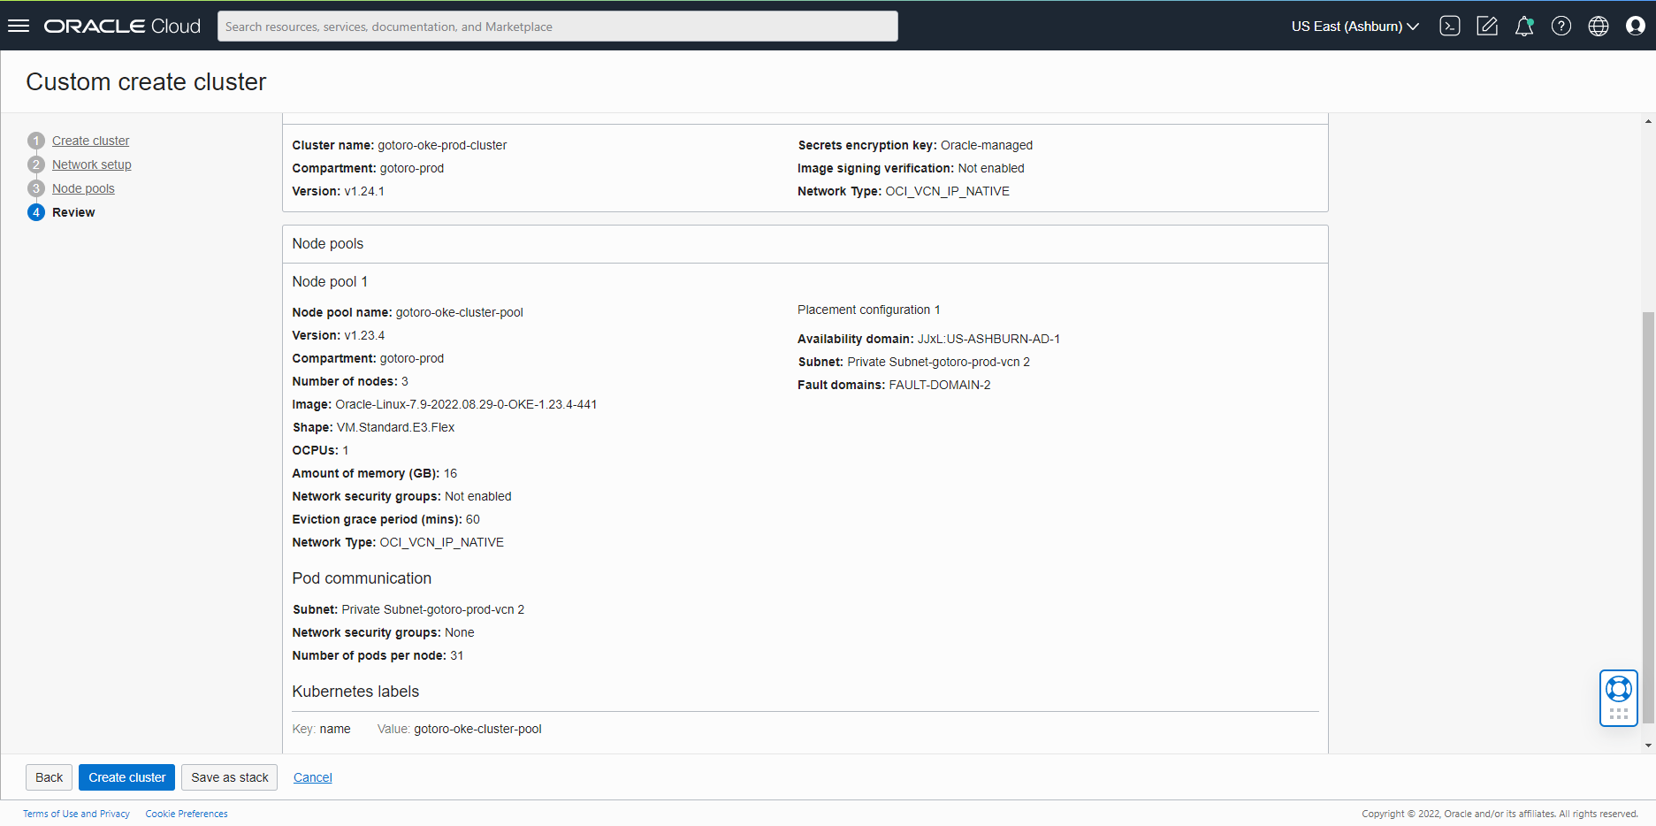

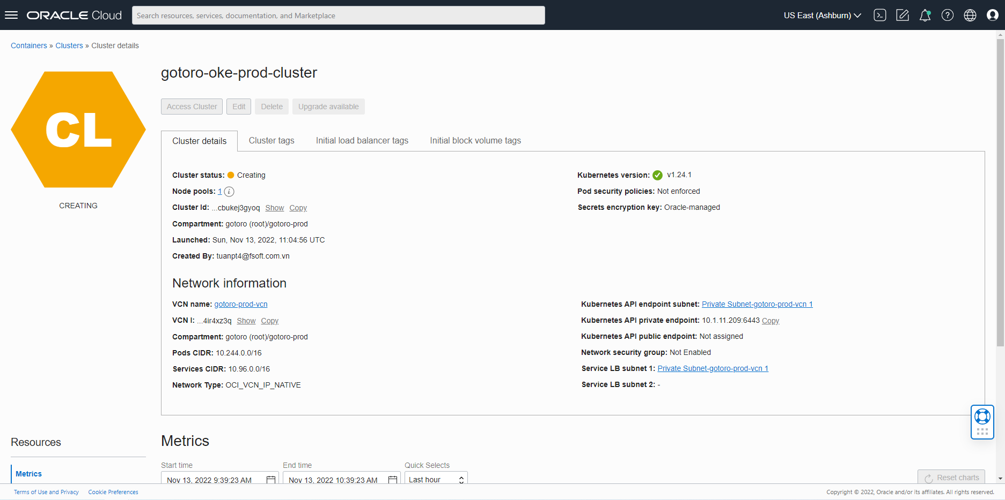

# Gotoro: Guideline to Connect to OKE

Step 1: Step 1: Login Oracle Cloud: [Oracle Cloud Infrastructure](https://cloud.oracle.com/?region=us-ashburn-1). Go to **Develoer Services** > **Kubernetes Cluster**.



Step 2: Change **Compartment** to gotoro-prod and chose cluster.

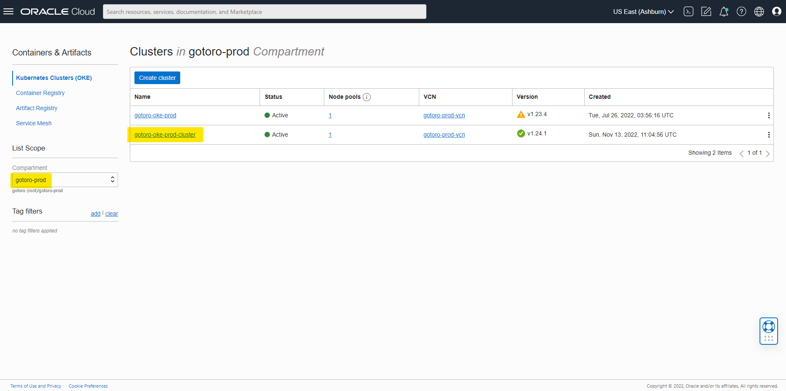

Step 3: Copy Cluster ID.

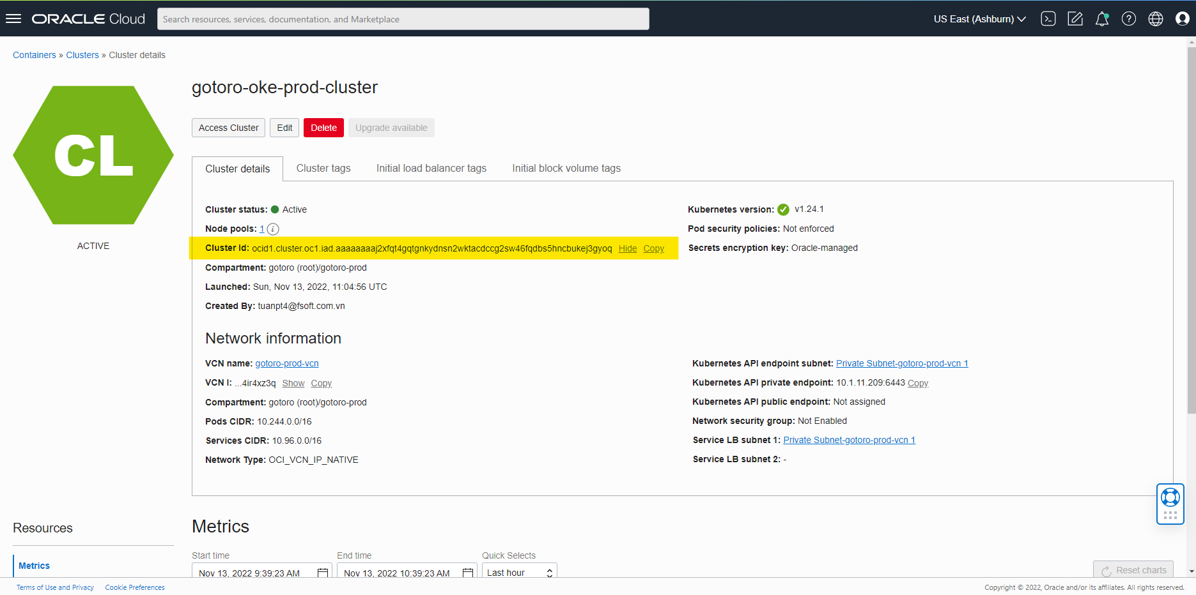

Step 4: SSH to Bastion VM by **dev-user.pem**.

ssh -i dev-user.pem opc@150.136.245.180 -p 443

Example:

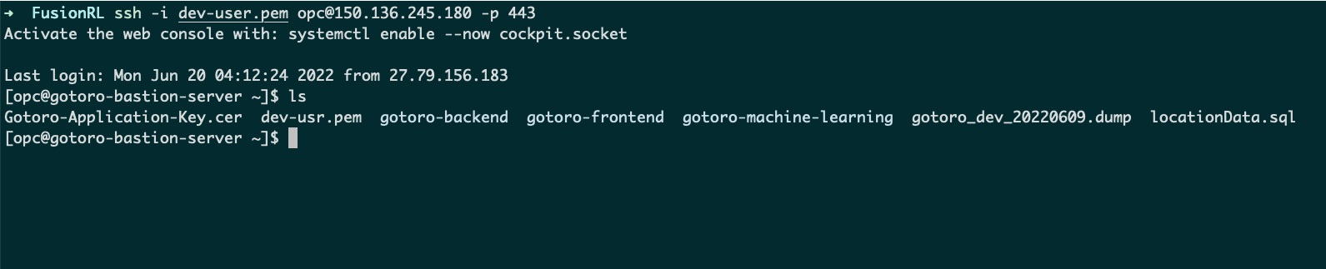

Step 5: Connect to OKE by oci command:

oci ce cluster create-kubeconfig --cluster-id ocid1.cluster.oc1.iad.aaaaaaaaj2xfqt4gqtgnkydnsn2wktacdccg2sw46fqdbs5hncbukej3gyoq --file $HOME/.kube/config --region us-ashburn-1 --token-version 2.0.0 --kube-endpoint PRIVATE_ENDPOINT

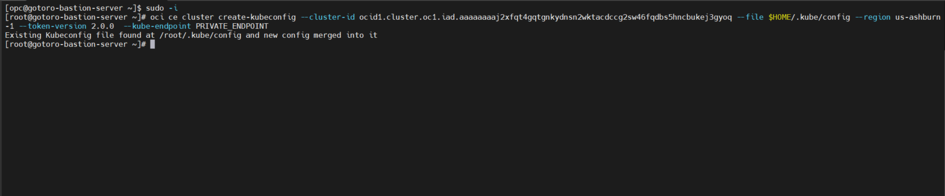

Step 4: Check connection status.

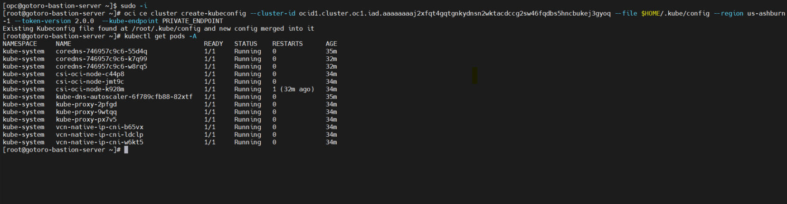

# Gotoro: Guideline to Install ArgoCD.

Step 1: Check OKE namespace.

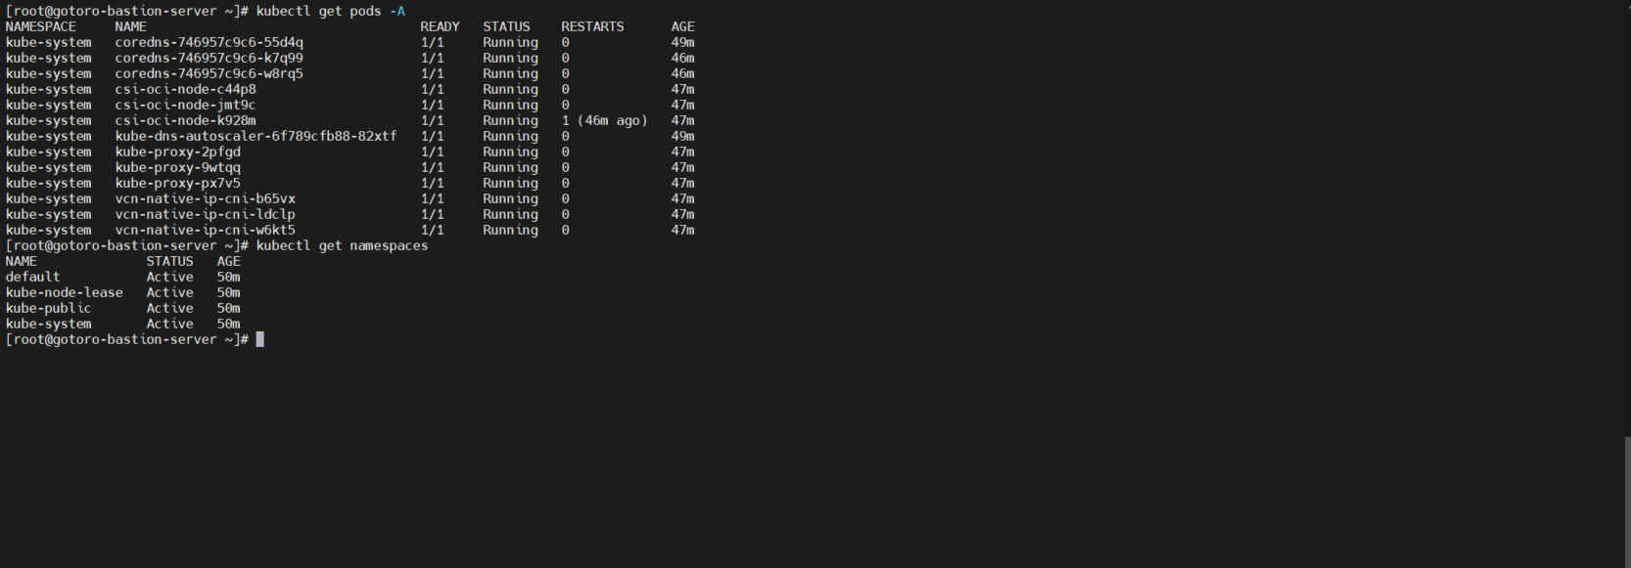

Step 2: Create namespace

kubectl create namespace argocd

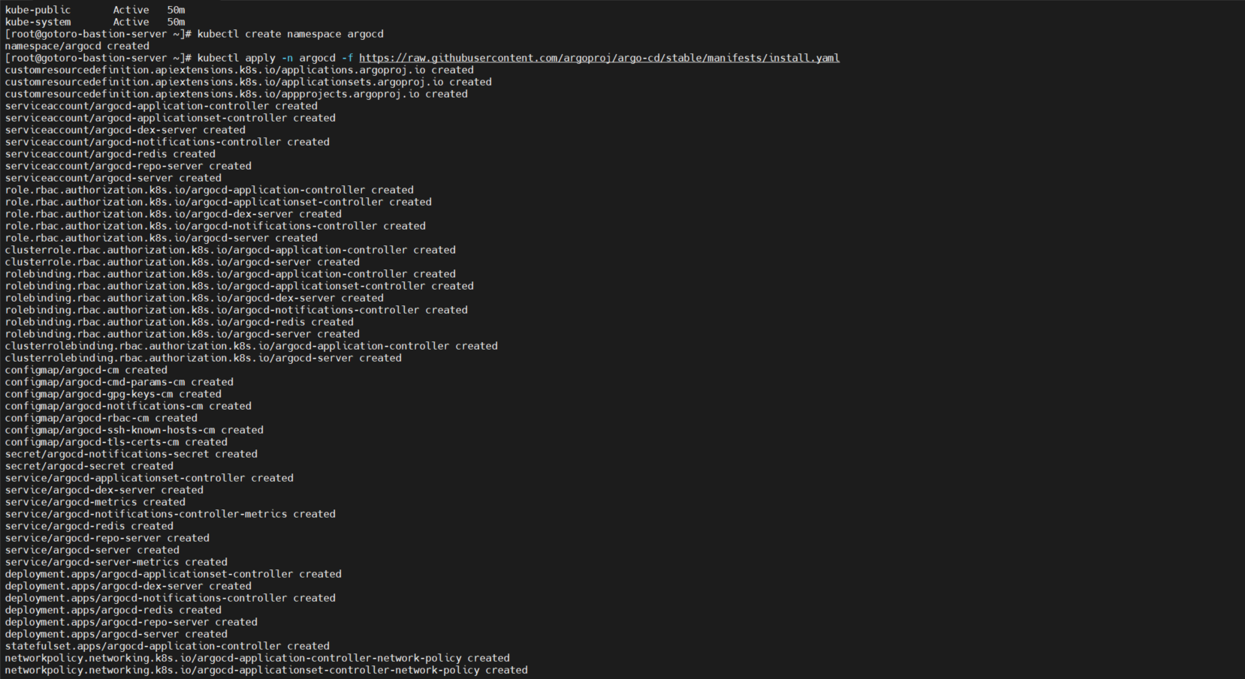

Step 5: Add helm repo.

helm repo add argo <https://argoproj.github.io/argo-helm>.

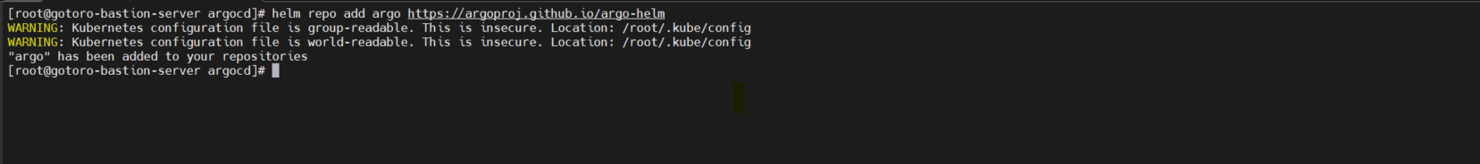

Step 6: Create file config for argocd.yaml

vi argocd.yaml

Value file:

redis-ha:

enabled: false

controller:

enableStatefulSet: true

minReplicas: 2

server:

service:

type: LoadBalancer

annotations:

# Create internal LB

service.beta.kubernetes.io/oci-load-balancer-internal: "true"

extraArgs:

- --insecure

autoscaling:

enabled: true

minReplicas: 2

repoServer:

autoscaling:

enabled: true

minReplicas: 1

Step 7: Install ArgoCD.

helm install -f argocd.yaml argocd-release argo/argo-cd -n argocd

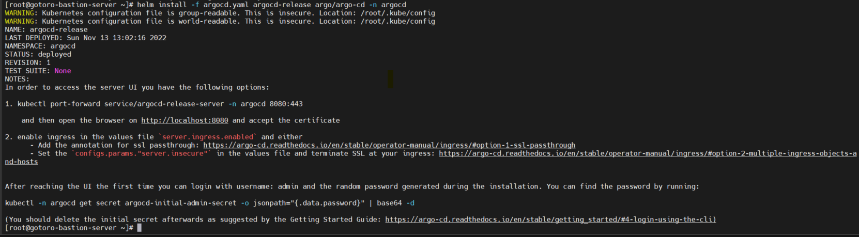

Step 8: Check Service



Step 9: Get argocd admin passoword

kubectl -n argocd get secret argocd-initial-admin-secret -o jsonpath="{.data.password}" | base64 -d



Step 10: Connect to Argocd

Open new terminal at folder dev-user.pem and run command.

ssh -i dev-user.pem -vNL 8081:<argocd-release-server external-IP>:8080 [opc@150.136.245..180](mailto:opc@150.136.245..180) –p 443

Open Browser with URL: localhost:8081. Login with user is admin and password at the previous step.

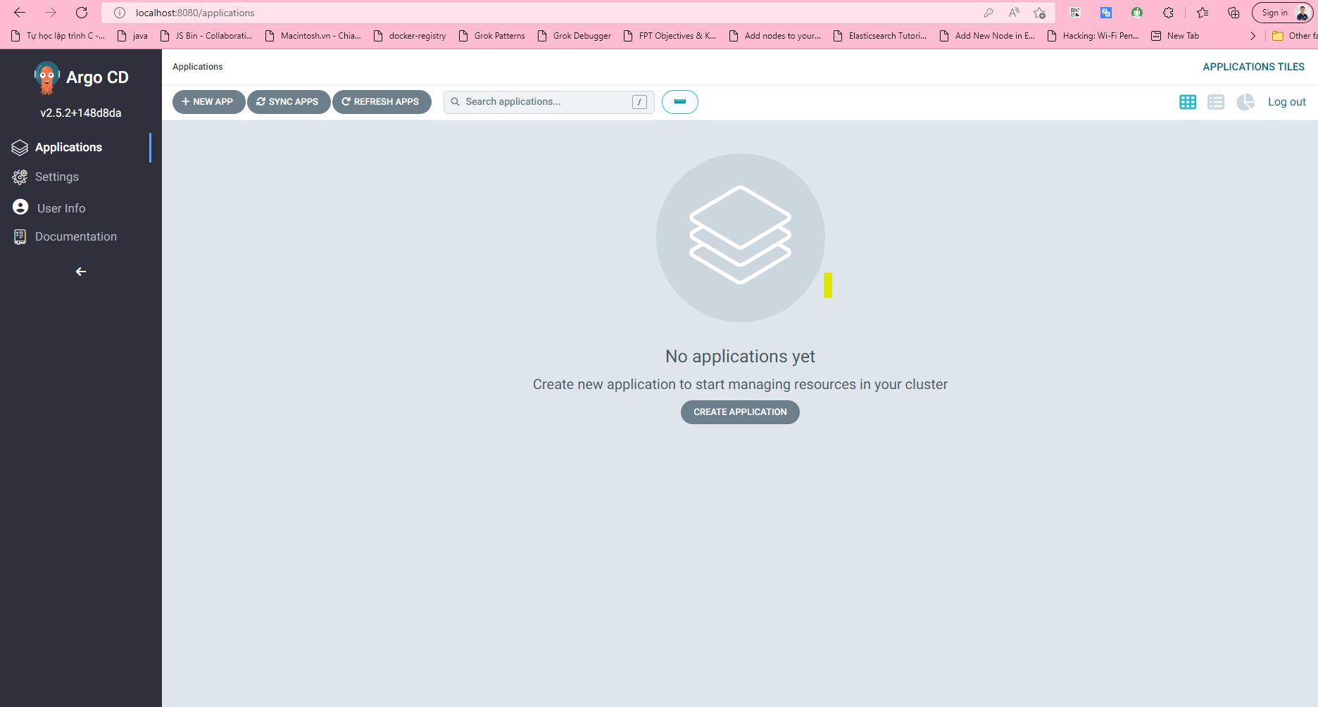

# Gotoro: Document for add repo helm chart on ArgoCD.

Step1: Add repo helm chart.

Connect to Argocd

Open new terminal at folder dev-user.pem and run command.

ssh -i dev-user.pem -vNL 8081:<argocd-release-server external-IP>:8080 [opc@150.136.245..180](mailto:opc@150.136.245..180) –p 443

Open Browser with URL: localhost:8081. Login with user is admin and password at the previous step.

Click to Settings.

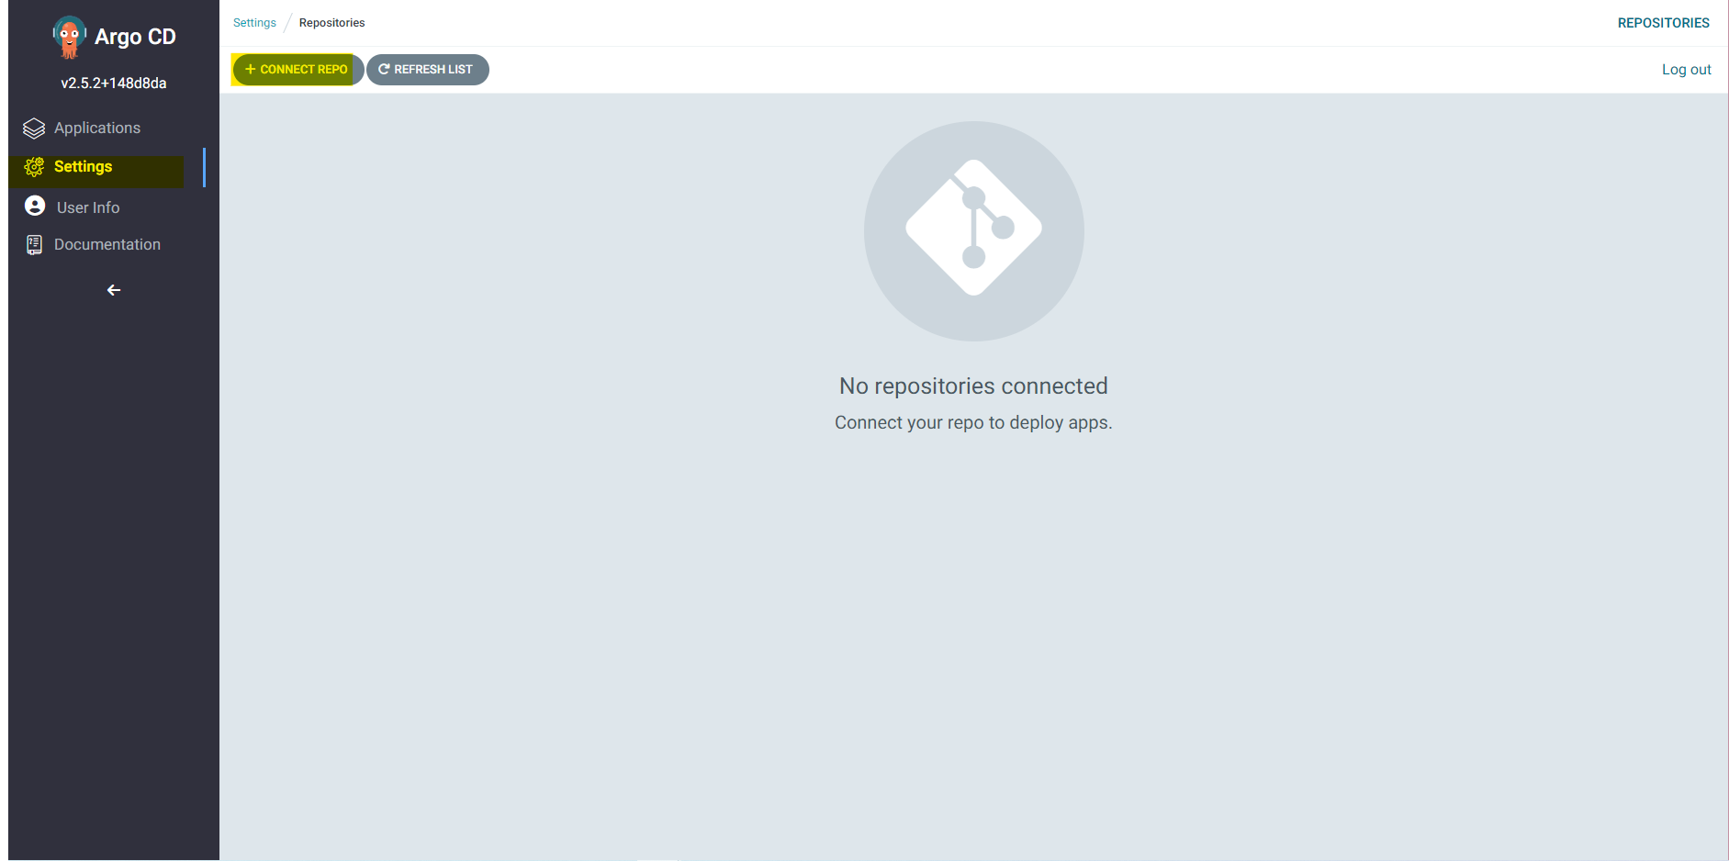

Fill information. URL: https://gotoro-gotorodev.developer.ocp.oraclecloud.com/gotoro-gotorodev/s/gotoro-gotorodev_gotoro-devops_52312/scm/gotoro-helm-chart.git

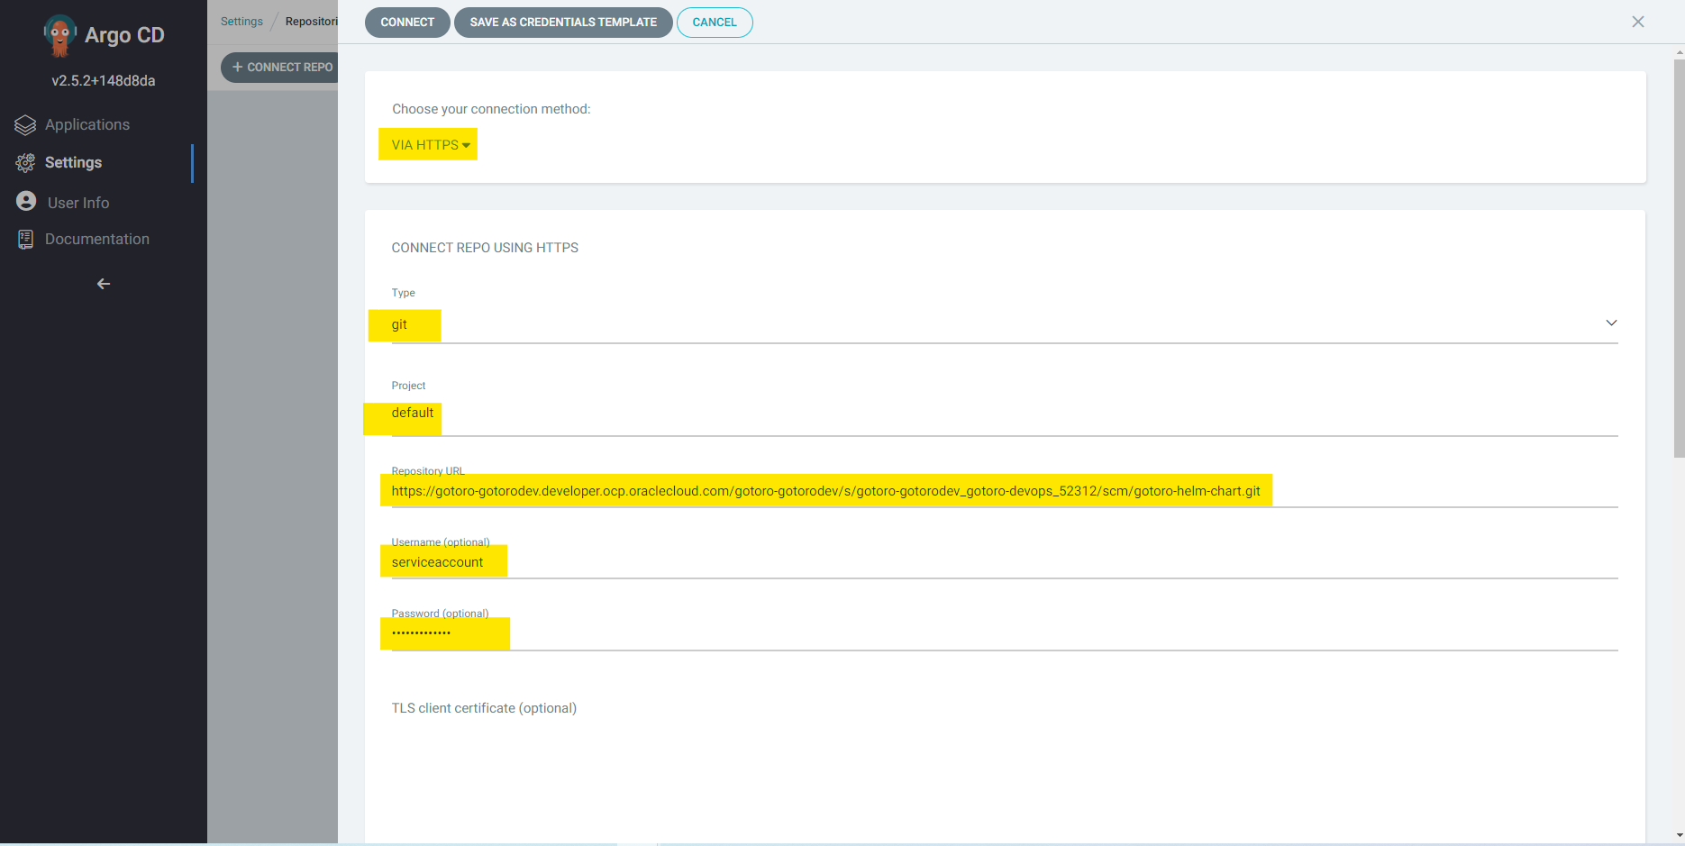

Connect.

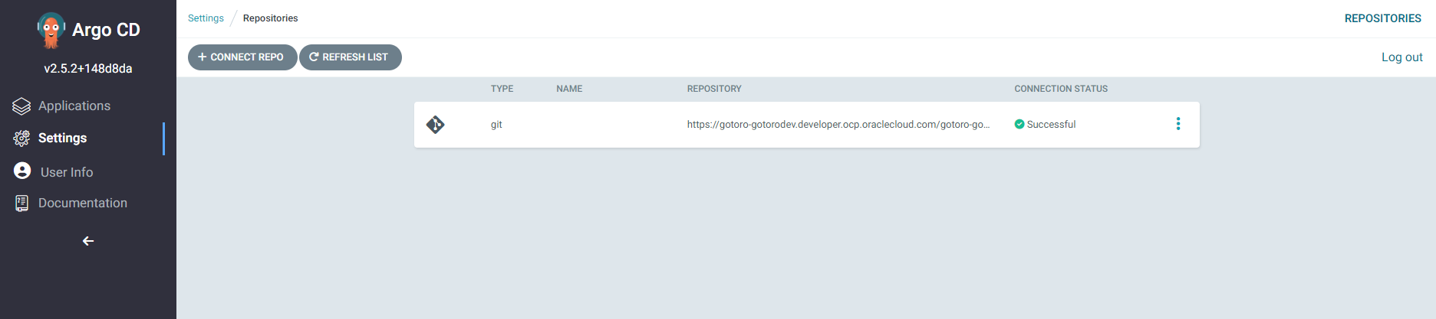

**End Guideline.**